## Chapter 2 Game Specifications

Tanks game is developed in this work. A snapshot of the game interface, when the game starts, is shown below:

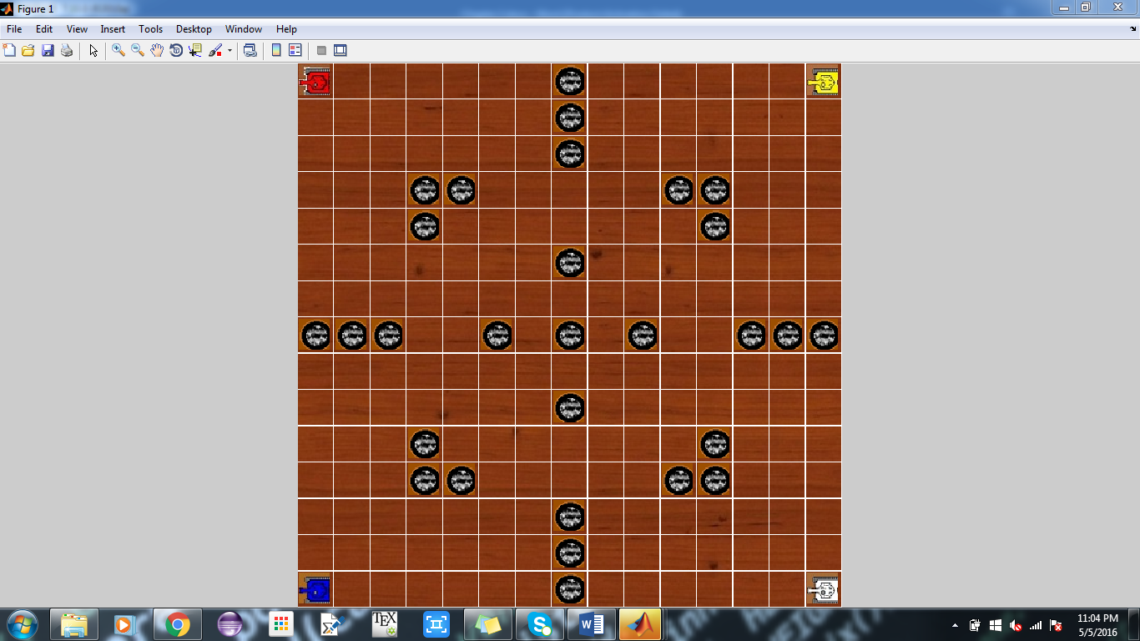

### Tanks and Stones

In this game, four tanks are there in the battle field and every tank has its own ‘field of vision’ which indicates the state of board visible to tank. Whenever a tank discovered a new cell (reached at a cell first time), its score is incremented by one, and destroying an opponent adds 50 to its score. The game finishes after a certain number of moves (for example 500 moves), and the player with the highest score wins the game.

Apart from tank, the battlefield contains stones/obstacles and the tanks can neither pass nor see through them.

### Possible moves

At a given instance, a tank can have a maximum of seven moves which are described below:

1. Move one step to East
2. Move one step to West
3. Move one step towards North
4. Move one step towards South
5. Change the direction by +90°
6. Change the direction by -90°
7. Launch Fire

Whenever a tank launches fire, every tank that comes in the column/row where fire is launched will be destroyed.

(Samuel, 2000)

Samuel, A. .L. 2000. Some Studies in Machine Learning Using the Game of Checkers. IBM Journal of Research and Development. 44(1/2), pp. 206-226.

IBM's Deep Blue defeated Garry Kasparov

(Cadwalladr, 2014)

Cadwalladr, C., 2014. Are the Robots about to Rise? Google’s new director of engineering thinks so…. *The Guardian*, *22*.

Aplha Go deafeated Lee Sedol

(Rutkin, 2016)

Rutkin, A., 2016. Anything you can do…. *New Scientist*, *229*(3065), pp.20-21.